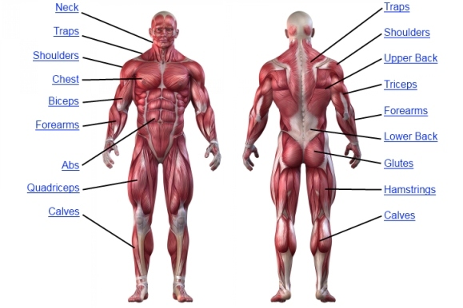 **COURSE SYLLABUS**

**Anatomy and Physiology**

**Instructor:** Mrs. Zhong

**Email:** lzhong@skahalb.org

**Course Description:** Anatomy and Physiology is a course designed for students who want to continue their study of the structure and function of the human body on a more challenging level. Our approach is a combined one, mixing factual knowledge of each individual system and organ with a broader view of the human body as a whole machine with all the parts working together in a concerted effort to maintain life. Significant time is spent discussing how the different systems relate to each other; ways in which they share and divide functions, and mechanisms of compensation by others when one begins to fail.

**Course Objective:** Upon the successful completion of this course, students will be able to explain how anatomy and physiology are related, name the levels of structural organization that make up the human body and explain how they are related. They will also be able to describe the developmental aspects of all the body systems and explain common diseases that affect the body systems.

**Course Materials:**

* Three-ring binder with College Ruled paper (not necessary if you are using iPad to take notes)
* Colored pencils (not necessary if you are using iPad to take notes)
* 3x5 index cards for studying/reviewing

**Grading Policy**



### Students will be evaluated using a variety of methods, including quizzes, tests, projects, and labs. More information concerning due dates will be available in class. Grades will be weighted and assessed as follows:

**Tests**: 40% **Participation**: 10%

**Quizzes**: 30% **Classwork & HW:** 20%

**Late Work Policy**

Assignments are due when the teacher collects them or we go over them at the beginning of class. Late assignments will be graded with a 50% deduction and are due the next day.

**Make-Up Work Policy**

Students are expected to make up missed work immediately upon returning to school. If an assignment was due on the first day of the absence, students should be prepared to hand the assignment in on the day they return to school. Students are expected to take the initiative in the “catching-up” process.

**Extra Credit**

Students will have several extra credit assignments available to them. In order to be eligible to earn these extra credit points, students must:

* Have no more than 4 absences. (Exceptions may be made)
* Have no more than 6 tardies.
* Have completed 80% of assignments and taken all tests.

**Cheating/Plagiarism**

Cheating and plagiarism in any form will not be tolerated. A student who copies another student’s work or who cheats on quizzes or test will get a 0 for that particular assignment or exam. Students giving work to others to copy, or who allow others to copy on quizzes or tests are equally guilty of cheating.

---------------------------------------------------------------------------------------------

Please have your parents read over the syllabus and the statement below. Return the bottom portion with your parent’s signature.

I have read over the syllabus for Anatomy. I understand the Grading Policy, Late Work Policy, Make-Up Work Policy, and Cheating/Plagiarism Policy

Parent Signature: ___________________________ Date:______________

Student Signature: __________________________ Date: _____________